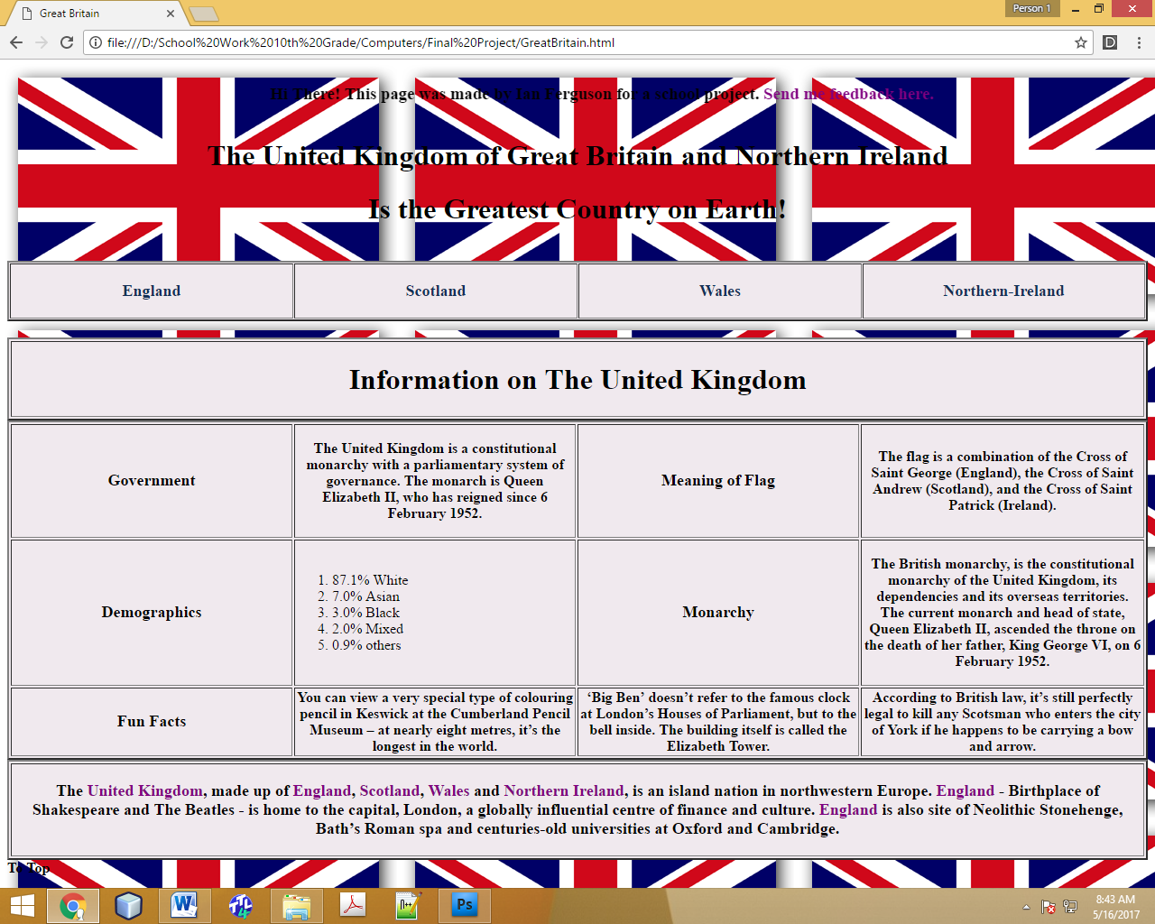

|  |
| --- |
| <!DOCTYPE html |
|  | PUBLIC "-//W3C//DTD XHTML 1.0 Transitional//EN" |
|  | "http://www.w3.org/TR/xhtml1/DTD/xhtml1-transitional.dtd"> |
|  | <html> |
|  | <head> <title> Great Britain </title> </head> |
|  | <style> |
|  | a:link.firstpara { |
|  | color: purple; |
|  | text-decoration: none} |
|  | a:visited.firstpara { |
|  | color: #901E1D; |
|  | text-decoration: none} |
|  | a:hover.firstpara { |
|  | color: red; |
|  | text-decoration: none} |
|  | a:active.firstpara { |
|  | color: hotpink; |
|  | text-decoration: none} |
|  | a:link.menu { |
|  | color: navy; |
|  | text-decoration: none} |
|  | a:visited.menu { |
|  | color: #123057; |
|  | text-decoration: none} |
|  | a:hover.menu { |
|  | color: #00477e; |
|  | text-decoration: none} |
|  | a:active.menu { |
|  | color: #0065b1; |
|  | text-decoration: none} |
|  | a:link.totop { |
|  | color: black; |
|  | text-decoration: none} |
|  | a:visited.totop { |
|  | color: black; |
|  | text-decoration: none} |
|  | a:hover.totop { |
|  | color: black; |
|  | text-decoration: none} |
|  | a:active.totop { |
|  | color: black; |
|  | text-decoration: none} |
|  | </style> |
|  | <body background="UK.png"> |
|  | <marquee> <h3 id="Top"> Hi There! This page was made by Ian Ferguson for a school project. <a href="<mailto:sammy4life9@gmail.com>" class="firstpara"> Send me feedback here. </a> </h3> </marquee> |
|  | <h1 align="center" style= "color:black"> The United Kingdom of Great Britain and Northern Ireland </h1> |
|  | <h1 align="center" style= "color:black"> Is the Greatest Country on Earth! </h1> |
|  | </br> |
|  | <table bgcolor="#f0e9ee" border="2" cellspacing="1" style="width:100%"> |
|  | <tbody> |
|  | <tr> |
|  | <th width="25%"> <a href="England.html" class="menu"> <p style="font-size:18px"> England </p> </a> </th> |
|  | <th width="25%"> <a href="Scotland.html" class="menu"> <p style="font-size:18px"> Scotland </p> </a> </th> |
|  | <th width="25%"> <a href="Wales.html" class="menu"> <p style="font-size:18px"> Wales </p> </a> </th> |
|  | <th width="25%"> <a href="NorthernIreland.html" class="menu"> <p style="font-size:18px"> Northern-Ireland </p> </a> </th> |
|  | </tr> |
|  | </tbody> |
|  | </table> |
|  | </br> |
|  | <table border="2" width="100%" bgcolor="#f0e9ee"> |
|  | <tbody> |
|  | <tr> |
|  | <th width="100%"> <h1 align="center"> Information on The United Kingdom </h1> </th> |
|  | </tr> |
|  | </tbody> |
|  | </table> |
|  | <table border="2" width="100%" bgcolor="#f0e9ee"> |
|  | <tbody> |
|  | <tr> |
|  | <th width="25%"> <p style="font-size:18px"> Government </p> </th> <th width="25%" align="center"> <p style="font-size:16px"> The United Kingdom is a constitutional monarchy with |
|  | a parliamentary system of governance. The monarch is Queen Elizabeth II, who has reigned since 6 February 1952. </p> </th> <th width="25%"> |
|  | <p style="font-size:18px"> Meaning of Flag </th> <th> <p style="font-size:16px"> The flag is a combination of the Cross of Saint George (England), the Cross of Saint Andrew (Scotland), |
|  | and the Cross of Saint Patrick (Ireland). </th> |
|  | </tr> |
|  | <tr> |
|  | <th width="25%" bgcolor="#f0e9ee"> <p style="font-size:18px"> Demographics </p> </th> <td width="25%"> <ol style="font-size:16px"> <li> 87.1% White </li> <li> 7.0% Asian </li> |
|  | <li> 3.0% Black </li> <li> 2.0% Mixed </li> <li> 0.9% others </li> </td> <th> <p style="font-size:18px"> Monarchy </p> </th> <th> <p style="font-size:16px"> The British |
|  | monarchy, is the constitutional monarchy of the United Kingdom, its dependencies and its overseas territories. The current monarch and head of state, Queen Elizabeth II, |
|  | ascended the throne on the death of her father, King George VI, on 6 February 1952. </p> </th> |
|  | </tr> |
|  | <tr> |
|  | <th width="25%" bgcolor="#f0e9ee"> <p style="font-size:18px"> Fun Facts </th> <th> You can view a very special type of colouring pencil in Keswick at the Cumberland Pencil |
|  | Museum – at nearly eight metres, it’s the longest in the world. </th> <th> ‘Big Ben’ doesn’t refer to the famous clock at London’s Houses of Parliament, but to the bell inside. |
|  | The building itself is called the Elizabeth Tower. </th> <th> According to British law, it’s still perfectly legal to kill any Scotsman who enters the city of York if he |
|  | happens to be carrying a bow and arrow. </th> |
|  | </tr> |
|  | </tbody> |
|  | </table> |
|  | <table border="2" bgcolor="#f0e9ee" width="100%"> |
|  | <tbody> |
|  | <tr> |
|  | <th> <p style="font-size:18px"> The <a href="<https://en.wikipedia.org/wiki/United_Kingdom>" class="firstpara">United Kingdom</a>, made up of <a href="<https://en.wikipedia.org/wiki/England>" class="firstpara">England</a>, <a href="<https://en.wikipedia.org/wiki/Scotland>"class="firstpara">Scotland</a>, <a href="<https://en.wikipedia.org/wiki/Wales>" class="firstpara">Wales</a> and <a href="<https://en.wikipedia.org/wiki/Northern_Ireland>" class="firstpara">Northern Ireland</a>, |
|  | is an island nation in northwestern Europe. <a href="<https://en.wikipedia.org/wiki/England>" class="firstpara">England</a> - Birthplace of Shakespeare and The Beatles - is home to the capital, London, a |
|  | globally influential centre of finance and culture. <a href="<https://en.wikipedia.org/wiki/England>" class="firstpara">England</a> is also site of Neolithic Stonehenge, Bath’s Roman spa and centuries-old universities at Oxford and Cambridge. </p> </th> |
|  | </tr> |
|  | </tbody> |
|  | </table> |
|  | <a href="#Top" class="totop"> <b> To Top </b> </a> |
|  | <!-- Ian Ferguson May 12, 2017 --> |
|  | </body> |
|  | </html> |

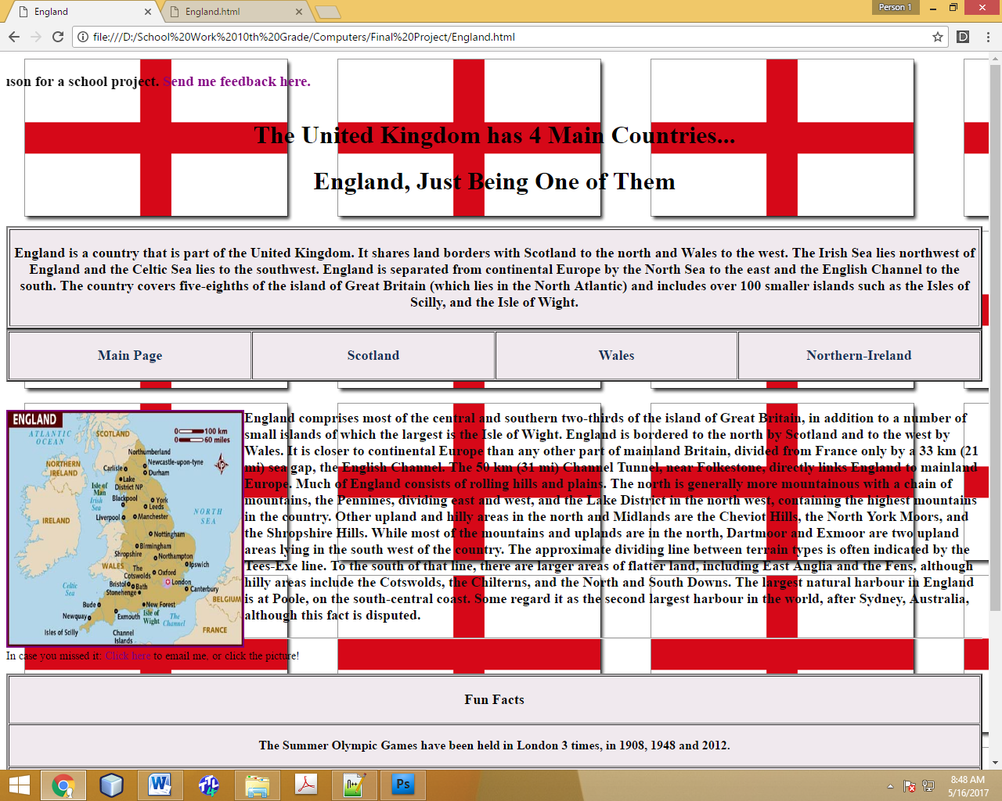

<!DOCTYPE html

PUBLIC "-//W3C//DTD XHTML 1.0 Transitional//EN"

"http://www.w3.org/TR/xhtml1/DTD/xhtml1-transitional.dtd">

<html>

<head> <title> England </title> </head>

<style>

a:link.firstpara {

color: purple;

text-decoration: none}

a:visited.firstpara {

color: #901E1D;

text-decoration: none}

a:hover.firstpara {

color: red;

text-decoration: none}

a:active.firstpara {

color: hotpink;

text-decoration: none}

a:link.menu {

color: navy;

text-decoration: none}

a:visited.menu {

color: #123057;

text-decoration: none}

a:hover.menu {

color: #00477e;

text-decoration: none}

a:active.menu {

color: #0065b1;

text-decoration: none}

a:link.totop {

color: black;

text-decoration: none}

a:visited.totop {

color: black;

text-decoration: none}

a:hover.totop {

color: black;

text-decoration: none}

a:active.totop {

color: black;

text-decoration: none}

</style>

<body background="Eng.png">

<marquee> <h3 id="Top"> Hi There! This page was made by Ian Ferguson for a school project. <a href="mailto:sammy4life9@gmail.com" class="firstpara"> Send me feedback here. </a> </h3> </marquee>

<h1 align="center" style= "color:black"> The United Kingdom has 4 Main Countries... </h1>

<h1 align="center" style= "color:black"> England, Just Being One of Them </h1>

</br>

<table border="2" bgcolor="#f0e9ee">

<tbody>

<tr>

<th> <p style="font-size:18px"> England is a country that is part of the United Kingdom. It shares land borders with Scotland to the north and Wales to the west.

The Irish Sea lies northwest of England and the Celtic Sea lies to the southwest. England is separated from continental Europe by the North Sea to the east and

the English Channel to the south. The country covers five-eighths of the island of Great Britain (which lies in the North Atlantic) and includes over 100 smaller

islands such as the Isles of Scilly, and the Isle of Wight. </p> </th>

</tr>

</tbody>

</table>

<table bgcolor="#f0e9ee" border="2" cellspacing="1" style="width:100%">

<tbody>

<tr>

<th width="25%"> <a href="GreatBritain.html" class="menu"> <p style="font-size:18px"> Main Page </p> </a> </th>

<th width="25%"> <a href="Scotland.html" class="menu"> <p style="font-size:18px"> Scotland </p> </a> </th>

<th width="25%"> <a href="Wales.html" class="menu"> <p style="font-size:18px"> Wales </p> </a> </th>

<th width="25%"> <a href="NorthernIreland.html" class="menu"> <p style="font-size:18px"> Northern-Ireland </p> </a> </th>

</tr>

</tbody>

</table>

</br>

<p style="font-size:18px; color:#0b0b0d"> <a href="mailto:sammy4life9@gmail.com" class="firstpara"><img src="mapeng.jpg" width="300" height="300" border="2" align="left"/></a> <b> England comprises most of the central and southern two-thirds of the island of

Great Britain, in addition to a number of small islands of which the largest is the Isle of Wight. England is bordered to the north by Scotland and to the west by Wales. It is closer

to continental Europe than any other part of mainland Britain, divided from France only by a 33 km (21 mi) sea gap, the English Channel. The 50 km (31 mi) Channel Tunnel, near

Folkestone, directly links England to mainland Europe. Much of England consists of rolling hills and plains. The north is generally more mountainous with a chain of mountains,

the Pennines, dividing east and west, and the Lake District in the north west, containing the highest mountains in the country.

Other upland and hilly areas in the north and Midlands are the Cheviot Hills, the North York Moors, and the Shropshire Hills. While most of the mountains and uplands are in the north,

Dartmoor and Exmoor are two upland areas lying in the south west of the country. The approximate dividing line between terrain types is often indicated by the Tees-Exe line. To the south

of that line, there are larger areas of flatter land, including East Anglia and the Fens, although hilly areas include the Cotswolds, the Chilterns, and the North and South Downs.

The largest natural harbour in England is at Poole, on the south-central coast. Some regard it as the second largest harbour in the world, after Sydney, Australia, although this fact

is disputed. </b> </p> <hr/> <p style="font-size:14px"> In case you missed it: <a href="mailto:sammy4life9@gmail.com" class="firstpara">Click here</a> to email me, or click the picture! </p>

<table bgcolor="#f0e9ee" border="2" cellspacing="1" style="width:100%">

<tbody>

<tr>

<th width="100%"> <p style="font-size:18px"> Fun Facts </p> </th>

</tr>

<tr>

<th width "50%"> <p style="font-size:16px"> The Summer Olympic Games have been held in London 3 times, in 1908, 1948 and 2012. </p> </th>

</tr>

<tr>

<th width "50%"> <p style="font-size:16px"> The official London home of the British monarch (king or queen) is Buckingham Palace. </p> </th>

</tr>

<tr>

<th width "50%"> <p style="font-size:16px"> England was the first industrialized nation after the industrial revolution that began around 1760. </p> </th>

</tr>

<tr>

<th width "50%"> <p style="font-size:16px"> The highest mountain in England is Scafell Pike, which stands at around 978 metres (3,209 ft) in height. </p> </th>

</tr>

<tr>

<th width "50%"> <p style="font-size:16px"> English computer scientist Tim Berners-Lee is credited with inventing the World Wide Web. </p> </th>

</tr>

</tbody>

</table>

<a href="#Top" class="totop"> <b> To Top </b> </a>

<!-- Ian Ferguson May 12, 2017 -->

</body>

</html>

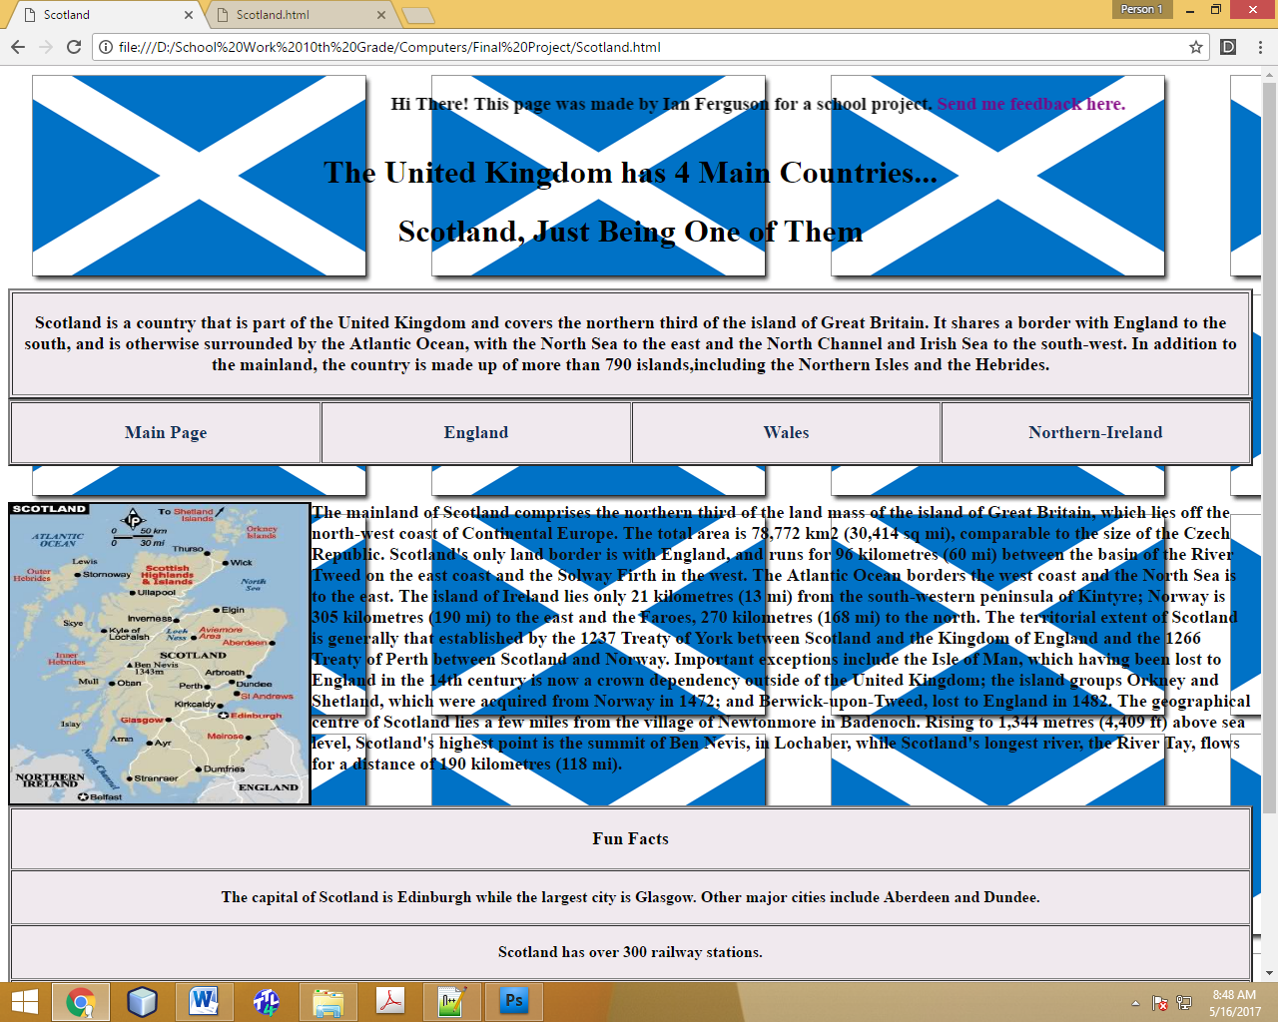

|  |
| --- |
| <!DOCTYPE html |
|  | PUBLIC "-//W3C//DTD XHTML 1.0 Transitional//EN" |
|  | "http://www.w3.org/TR/xhtml1/DTD/xhtml1-transitional.dtd"> |
|  | <html> |
|  | <head> <title> Scotland </title> </head> |
|  | <style> |
|  | a:link.firstpara { |
|  | color: purple; |
|  | text-decoration: none} |
|  | a:visited.firstpara { |
|  | color: #901E1D; |
|  | text-decoration: none} |
|  | a:hover.firstpara { |
|  | color: red; |
|  | text-decoration: none} |
|  | a:active.firstpara { |
|  | color: hotpink; |
|  | text-decoration: none} |
|  | a:link.menu { |
|  | color: navy; |
|  | text-decoration: none} |
|  | a:visited.menu { |
|  | color: #123057; |
|  | text-decoration: none} |
|  | a:hover.menu { |
|  | color: #00477e; |
|  | text-decoration: none} |
|  | a:active.menu { |
|  | color: #0065b1; |
|  | text-decoration: none} |
|  | a:link.totop { |
|  | color: black; |
|  | text-decoration: none} |
|  | a:visited.totop { |
|  | color: black; |
|  | text-decoration: none} |
|  | a:hover.totop { |
|  | color: black; |
|  | text-decoration: none} |
|  | a:active.totop { |
|  | color: black; |
|  | text-decoration: none} |
|  | </style> |
|  | <body background="Scottish3.png"> |
|  | <marquee> <h3 id="Top"> Hi There! This page was made by Ian Ferguson for a school project. <a href="<mailto:sammy4life9@gmail.com>" class="firstpara"> Send me feedback here. </a> </h3> </marquee> |
|  | <h1 align="center" style= "color:black"> The United Kingdom has 4 Main Countries... </h1> |
|  | <h1 align="center" style= "color:black"> Scotland, Just Being One of Them </h1> |
|  | </br> |
|  | <table border="2" bgcolor="#f0e9ee"> |
|  | <tbody> |
|  | <tr> |
|  | <th> <p style="font-size:18px"> Scotland is a country that is part of the United Kingdom and covers the northern third of the island of Great Britain. It shares a border with |
|  | England to the south, and is otherwise surrounded by the Atlantic Ocean, with the North Sea to the east and the North Channel and Irish Sea to the south-west. In addition to the |
|  | mainland, the country is made up of more than 790 islands,including the Northern Isles and the Hebrides. </p> </th> |
|  | </tr> |
|  | </tbody> |
|  | </table> |
|  | <table bgcolor="#f0e9ee" border="2" cellspacing="1" style="width:100%"> |
|  | <tbody> |
|  | <tr> |
|  | <th width="25%"> <a href="GreatBritain.html" class="menu"> <p style="font-size:18px"> Main Page </p> </a> </th> |
|  | <th width="25%"> <a href="England.html" class="menu"> <p style="font-size:18px"> England </p> </a> </th> |
|  | <th width="25%"> <a href="Wales.html" class="menu"> <p style="font-size:18px"> Wales </p> </a> </th> |
|  | <th width="25%"> <a href="NorthernIreland.html" class="menu"> <p style="font-size:18px"> Northern-Ireland </p> </a> </th> |
|  | </tr> |
|  | </table> |
|  | </br> |
|  | <p style="font-size:18px; color:#0b0b0d"> <img src="333.jpg" width="300" height="300" border="2" align="left"/> <b> The mainland of Scotland comprises the northern third of the |
|  | land mass of the island of Great Britain, which lies off the north-west coast of Continental Europe. The total area is 78,772 km2 (30,414 sq mi), comparable to the size of the |
|  | Czech Republic. Scotland's only land border is with England, and runs for 96 kilometres (60 mi) between the basin of the River Tweed on the east coast and the Solway Firth in the west. |
|  | The Atlantic Ocean borders the west coast and the North Sea is to the east. The island of Ireland lies only 21 kilometres (13 mi) from the south-western peninsula of Kintyre; Norway |
|  | is 305 kilometres (190 mi) to the east and the Faroes, 270 kilometres (168 mi) to the north. The territorial extent of Scotland is generally that established by the 1237 Treaty of |
|  | York between Scotland and the Kingdom of England and the 1266 Treaty of Perth between Scotland and Norway. Important exceptions include the Isle of Man, which having been lost to |
|  | England in the 14th century is now a crown dependency outside of the United Kingdom; the island groups Orkney and Shetland, which were acquired from Norway in 1472; and |
|  | Berwick-upon-Tweed, lost to England in 1482. The geographical centre of Scotland lies a few miles from the village of Newtonmore in Badenoch. Rising to 1,344 metres (4,409 ft) |
|  | above sea level, Scotland's highest point is the summit of Ben Nevis, in Lochaber, while Scotland's longest river, the River Tay, flows for a distance of 190 |
|  | kilometres (118 mi). </b> </p> |
|  | <table bgcolor="#f0e9ee" border="2" cellspacing="1" style="width:100%"> |
|  | <tbody> |
|  | <tr> |
|  | <th width="100%"> <p style="font-size:18px"> Fun Facts </p> </th> |
|  | </tr> |
|  | <tr> |
|  | <th width "50%"> <p style="font-size:16px"> The capital of Scotland is Edinburgh while the largest city is Glasgow. Other major cities include Aberdeen and Dundee. </p> </th> |
|  | </tr> |
|  | <tr> |
|  | <th width "50%"> <p style="font-size:16px"> Scotland has over 300 railway stations. </p> </th> |
|  | </tr> |
|  | <tr> |
|  | <th width "50%"> <p style="font-size:16px"> Scotland has a unique culture with traditions such as bagpipes, kilts and highland dancing. </p> </th> |
|  | </tr> |
|  | <tr> |
|  | <th width "50%"> <p style="font-size:16px"> Scotland is located in Europe, at the northern end of Great Britain. </p> </th> |
|  | </tr> |
|  | <tr> |
|  | <th width "50%"> <p style="font-size:16px"> The highest mountain in Scotland is Ben Nevis which stands at a height of 1344 metres, <em>or 4409 feet</em>. </p> </th> |
|  | </tr> |
|  | </tbody> |
|  | </table> |
|  | <a href="#Top" class="totop"> <b> To Top </b> </a> |
|  | <!-- Ian Ferguson May 12, 2017 --> |
|  | </body> |
|  | </html> |

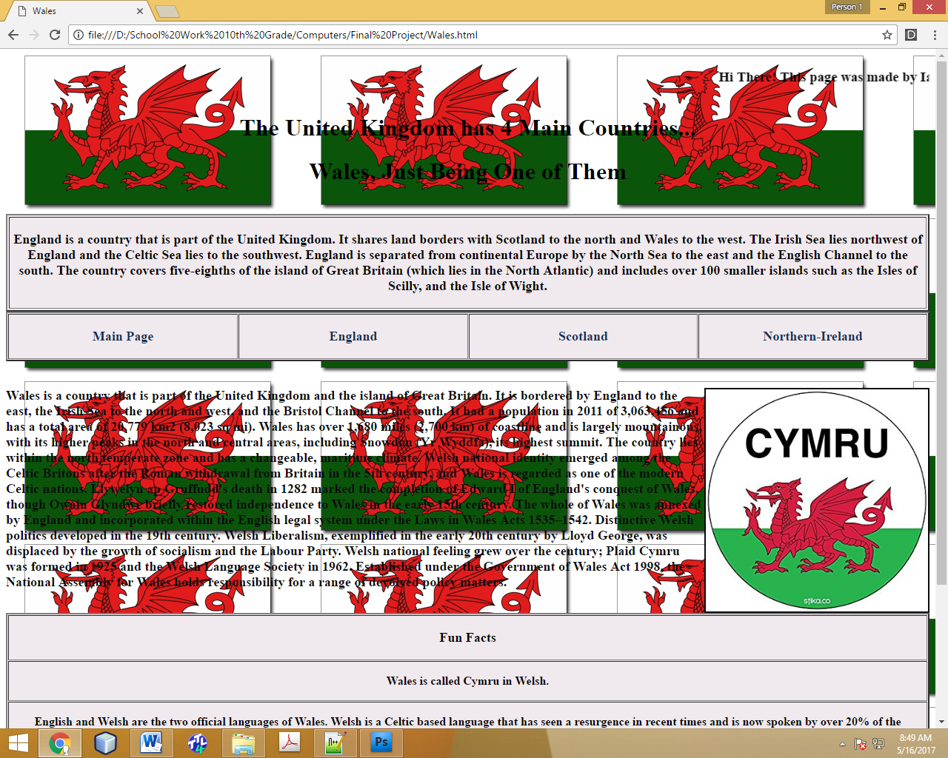

|  |
| --- |
| <!DOCTYPE html |
|  | PUBLIC "-//W3C//DTD XHTML 1.0 Transitional//EN" |
|  | "http://www.w3.org/TR/xhtml1/DTD/xhtml1-transitional.dtd"> |
|  | <html> |
|  | <head> <title> Wales </title> </head> |
|  | <style> |
|  | a:link.firstpara { |
|  | color: purple; |
|  | text-decoration: none} |
|  | a:visited.firstpara { |
|  | color: #901E1D; |
|  | text-decoration: none} |
|  | a:hover.firstpara { |
|  | color: red; |
|  | text-decoration: none} |
|  | a:active.firstpara { |
|  | color: hotpink; |
|  | text-decoration: none} |
|  | a:link.menu { |
|  | color: navy; |
|  | text-decoration: none} |
|  | a:visited.menu { |
|  | color: #123057; |
|  | text-decoration: none} |
|  | a:hover.menu { |
|  | color: #00477e; |
|  | text-decoration: none} |
|  | a:active.menu { |
|  | color: #0065b1; |
|  | text-decoration: none} |
|  | a:link.totop { |
|  | color: black; |
|  | text-decoration: none} |
|  | a:visited.totop { |
|  | color: black; |
|  | text-decoration: none} |
|  | a:hover.totop { |
|  | color: black; |
|  | text-decoration: none} |
|  | a:active.totop { |
|  | color: black; |
|  | text-decoration: none} |
|  | </style> |
|  | <body background="welsh.png"> |
|  | <marquee> <h3 id="Top"> Hi There! This page was made by Ian Ferguson for a school project. <a href="<mailto:sammy4life9@gmail.com>" class="firstpara"> Send me feedback here. </a> </h3> </marquee> |
|  | <h1 align="center" style= "color:black"> The United Kingdom has 4 Main Countries... </h1> |
|  | <h1 align="center" style= "color:black"> Wales, Just Being One of Them </h1> |
|  | </br> |
|  | <table border="2" bgcolor="#f0e9ee"> |
|  | <tbody> |
|  | <tr> |
|  | <th> <p style="font-size:18px"> England is a country that is part of the United Kingdom. It shares land borders with Scotland to the north and Wales to the west. |
|  | The Irish Sea lies northwest of England and the Celtic Sea lies to the southwest. England is separated from continental Europe by the North Sea to the east and |
|  | the English Channel to the south. The country covers five-eighths of the island of Great Britain (which lies in the North Atlantic) and includes over 100 smaller |
|  | islands such as the Isles of Scilly, and the Isle of Wight. </p> </th> |
|  | </tr> |
|  | </tbody> |
|  | </table> |
|  | <table bgcolor="#f0e9ee" border="2" cellspacing="1" style="width:100%"> |
|  | <tbody> |
|  | <tr> |
|  | <th width="25%"> <a href="GreatBritain.html" class="menu"> <p style="font-size:18px"> Main Page </p> </a> </th> |
|  | <th width="25%"> <a href="England.html" class="menu"> <p style="font-size:18px"> England </p> </a> </th> |
|  | <th width="25%"> <a href="Scotland.html" class="menu"> <p style="font-size:18px"> Scotland </p> </a> </th> |
|  | <th width="25%"> <a href="NorthernIreland.html" class="menu"> <p style="font-size:18px"> Northern-Ireland </p> </a> </th> |
|  | </tr> |
|  | </table> |
|  | </br> |
|  | <p style="font-size:18px; color:#0b0b0d" bgcolor="white"> <img src="1.jpg" width="300" height="300" border="2" align="right"/> <b> Wales is a country that is part of the United Kingdom and the |
|  | island of Great Britain. It is bordered by England to the east, the Irish Sea to the north and west, and the Bristol Channel to the south. It had a population in 2011 of |
|  | 3,063,456 and has a total area of 20,779 km2 (8,023 sq mi). Wales has over 1,680 miles (2,700 km) of coastline and is largely mountainous, with its higher peaks in the north and |
|  | central areas, including Snowdon (Yr Wyddfa), its highest summit. The country lies within the north temperate zone and has a changeable, maritime climate. Welsh national identity |
|  | emerged among the Celtic Britons after the Roman withdrawal from Britain in the 5th century, and Wales is regarded as one of the modern Celtic nations. Llywelyn ap Gruffudd's death |
|  | in 1282 marked the completion of Edward I of England's conquest of Wales, though Owain Glyndŵr briefly restored independence to Wales in the early 15th century. The whole of Wales was |
|  | annexed by England and incorporated within the English legal system under the Laws in Wales Acts 1535–1542. Distinctive Welsh politics developed in the 19th century. Welsh Liberalism, |
|  | exemplified in the early 20th century by Lloyd George, was displaced by the growth of socialism and the Labour Party. Welsh national feeling grew over the century; Plaid Cymru was formed |
|  | in 1925 and the Welsh Language Society in 1962. Established under the Government of Wales Act 1998, the National Assembly for Wales holds responsibility for a range of devolved policy |
|  | matters. </b> </p> |
|  | <table bgcolor="#f0e9ee" border="2" cellspacing="1" style="width:100%"> |
|  | <tbody> |
|  | <tr> |
|  | <th width="100%"> <p style="font-size:18px"> Fun Facts </p> </th> |
|  | </tr> |
|  | <tr> |
|  | <th width "50%"> <p style="font-size:16px"> Wales is called Cymru in Welsh. </p> </th> |
|  | </tr> |
|  | <tr> |
|  | <th width "50%"> <p style="font-size:16px"> English and Welsh are the two official languages of Wales. Welsh is a Celtic based language that has seen a resurgence in recent |
|  | times and is now spoken by over 20% of the population. </p> </th> |
|  | </tr> |
|  | <tr> |
|  | <th width "50%"> <p style="font-size:16px"> The country of Wales is said to contain more castles per square mile than any other country in the world. </p> </th> |
|  | </tr> |
|  | <tr> |
|  | <th width "50%"> <p style="font-size:16px"> Cardiff's Millennium Stadium has the largest retractable roof of any sports stadium in the world. </p> </th> |
|  | </tr> |
|  | <tr> |
|  | <th width "50%"> <p style="font-size:16px"> Cardiff is the largest city and also the capital of Wales. </p> </th> |
|  | </tr> |
|  | </tbody> |
|  | </table> |
|  | <a href="#Top" class="totop"> <b> To Top </b> </a> |
|  | <!-- Ian Ferguson May 12, 2017 --> |
|  | </body> |
|  | </html> |

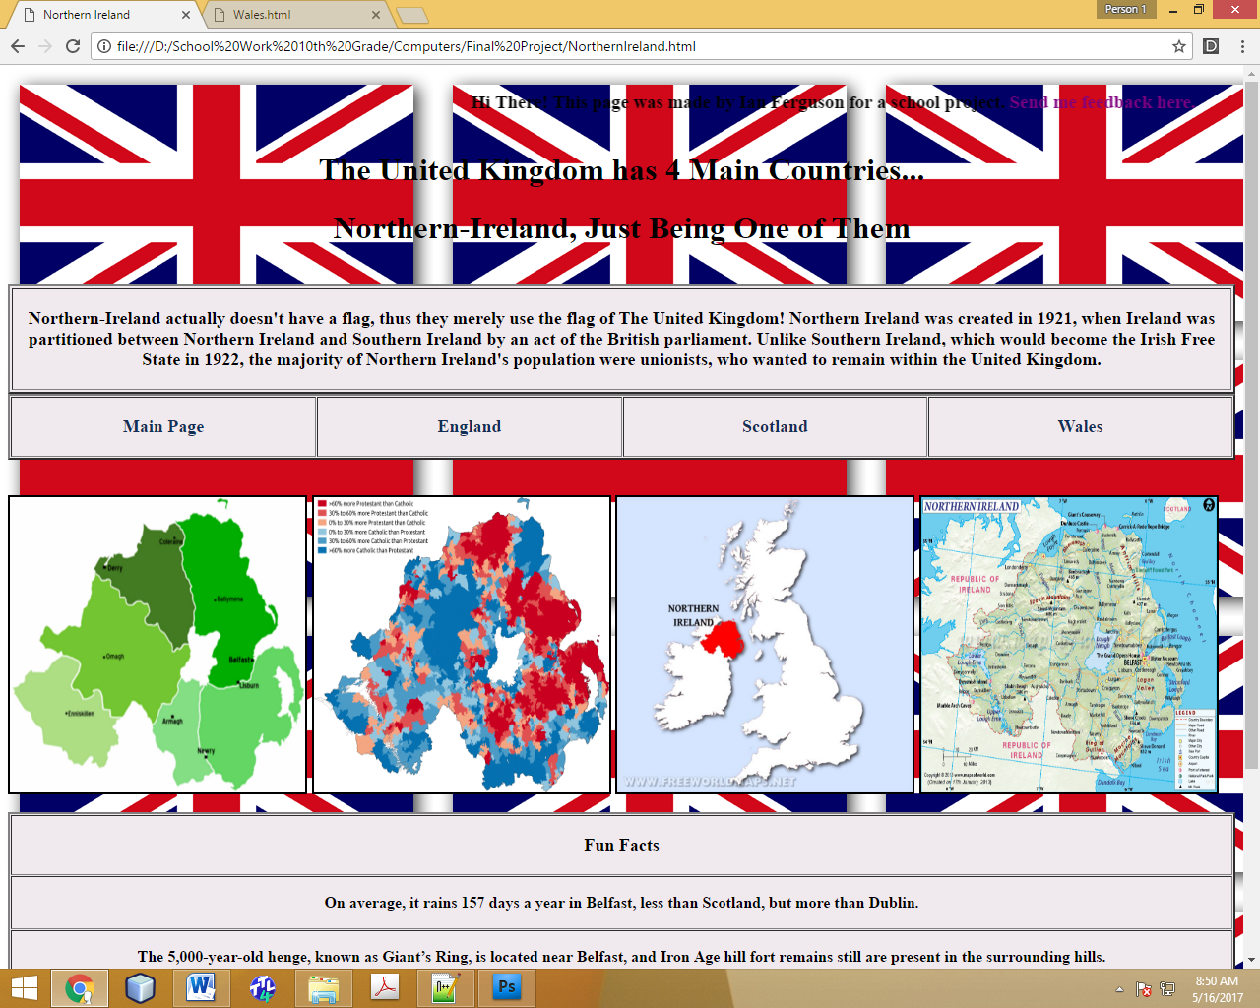

|  |
| --- |
| <!DOCTYPE html |
|  | PUBLIC "-//W3C//DTD XHTML 1.0 Transitional//EN" |
|  | "http://www.w3.org/TR/xhtml1/DTD/xhtml1-transitional.dtd"> |
|  | <html> |
|  | <head> <title> Northern Ireland </title> </head> |
|  | <style> |
|  | a:link.firstpara { |
|  | color: purple; |
|  | text-decoration: none} |
|  | a:visited.firstpara { |
|  | color: #901E1D; |
|  | text-decoration: none} |
|  | a:hover.firstpara { |
|  | color: red; |
|  | text-decoration: none} |
|  | a:active.firstpara { |
|  | color: hotpink; |
|  | text-decoration: none} |
|  | a:link.menu { |
|  | color: navy; |
|  | text-decoration: none} |
|  | a:visited.menu { |
|  | color: #123057; |
|  | text-decoration: none} |
|  | a:hover.menu { |
|  | color: #00477e; |
|  | text-decoration: none} |
|  | a:active.menu { |
|  | color: #0065b1; |
|  | text-decoration: none} |
|  | a:link.totop { |
|  | color: black; |
|  | text-decoration: none} |
|  | a:visited.totop { |
|  | color: black; |
|  | text-decoration: none} |
|  | a:hover.totop { |
|  | color: black; |
|  | text-decoration: none} |
|  | a:active.totop { |
|  | color: black; |
|  | text-decoration: none} |
|  | </style> |
|  | <body background="UK.png"> |
|  | <marquee> <h3 id="Top"> Hi There! This page was made by Ian Ferguson for a school project. <a href="<mailto:sammy4life9@gmail.com>" class="firstpara"> Send me feedback here. </a> </h3> </marquee> |
|  | <h1 align="center" style= "color:black"> The United Kingdom has 4 Main Countries... </h1> |
|  | <h1 align="center" style= "color:black"> Northern-Ireland, Just Being One of Them </h1> |
|  | </br> |
|  | <table border="2" bgcolor="#f0e9ee"> |
|  | <tbody> |
|  | <tr> |
|  | <th> <p style="font-size:18px"> Northern-Ireland actually doesn't have a flag, thus they merely use the flag of The United Kingdom! Northern Ireland was created in 1921, |
|  | when Ireland was partitioned between Northern Ireland and Southern Ireland by an act of the British parliament. Unlike Southern Ireland, which would become the Irish Free |
|  | State in 1922, the majority of Northern Ireland's population were unionists, who wanted to remain within the United Kingdom. </p> </th> |
|  | </tr> |
|  | </tbody> |
|  | </table> |
|  | <table bgcolor="#f0e9ee" border="2" cellspacing="1" style="width:100%"> |
|  | <tbody> |
|  | <tr> |
|  | <th width="25%"> <a href="GreatBritain.html" class="menu"> <p style="font-size:18px"> Main Page </p> </a> </th> |
|  | <th width="25%"> <a href="England.html" class="menu"> <p style="font-size:18px"> England </p> </a> </th> |
|  | <th width="25%"> <a href="Scotland.html" class="menu"> <p style="font-size:18px"> Scotland </p> </a> </th> |
|  | <th width="25%"> <a href="Wales.html" class="menu"> <p style="font-size:18px"> Wales </p> </a> </th> |
|  | </tr> |
|  | </table> |
|  | </br> |
|  | <p style="font-size:18px"> <img src="north.png" width="300" height="300" border="2" align="middle"/> |
|  | <img src="2.png" width="300" height="300" border="2" align="middle"/> <img src="5.jpg" width="300" height="300" border="2" align="middle"/> |
|  | <img src="4.gif" width="300" height="300" border="2" align="middle"/> </p> |
|  | <table bgcolor="#f0e9ee" border="2" cellspacing="1" style="width:100%"> |
|  | <tbody> |
|  | <tr> |
|  | <th width="100%"> <p style="font-size:18px"> Fun Facts </p> </th> |
|  | </tr> |
|  | <tr> |
|  | <th width "50%"> <p style="font-size:16px"> On average, it rains 157 days a year in Belfast, less than Scotland, but more than Dublin. </p> </th> |
|  | </tr> |
|  | <tr> |
|  | <th width "50%"> <p style="font-size:16px"> The 5,000-year-old henge, known as Giant’s Ring, is located near Belfast, and Iron Age hill fort remains still are present in |
|  | the surrounding hills. </p> </th> |
|  | </tr> |
|  | <tr> |
|  | <th width "50%"> <p style="font-size:16px"> While Belfast stayed a small settlement during the Middle Ages, the city played a leading role in the Industrial Revolution and was |
|  | Ireland’s largest city around the early part of the 20th century. </p> </th> |
|  | </tr> |
|  | <tr> |
|  | <th width "50%"> <p style="font-size:16px"> With a majority of the residents in the northern part of Ireland being Protestant descendants of colonists from Great Britain, the |
|  | British parliament partitioned Northern and Southern Ireland in 1921, creating Northern Ireland. </p> </th> |
|  | </tr> |
|  | <tr> |
|  | <th width "50%"> <p style="font-size:16px"> Surrounded by mountains that create a micro-climate conducive to horticulture, Belfast contains 3,000 acres of parks, many of them |
|  | forested. </p> </th> |
|  | </tr> |
|  | </tbody> |
|  | </table> |
|  | <a href="#Top" class="totop"> <b> To Top </b> </a> |
|  | <!-- Ian Ferguson May 12, 2017 --> |
|  | </body> |
|  | </html> |